Points West Living Moose Jaw
December 2025






David Z - December 1
Sharon M - December 4
Charlotte S - December 5
Gladys B - December 6
Shirley B - December 7
Delores P - December 11
Noella P - December 13
Vern O - December 13

___________________________________________________________________

Arlene C

__________________________________________________________________________________________________
A huge shout out to everyone who donated candy & helped to hand out the halloween candy. We had a total of 76 kids that came out.

A BIG thank you to everyone who donated to the “I Bought A Lunch” Program. Together, we collected $156.00 which will buy 78 lunches!
Amazing!!
___________________________________________________________________
BINGO CHANGES:
Effective January 2026, we will start to charge .50 cents per player. The caller will collect the money each night before the first game is called. This extra money will cover the cost of the envelope prizes.
You will continue to play with nickels; the pots and prizes will remain the same.
The only change is that you will now pay to play.
Father Nestor will only be here on Friday, Dec 15 @ 10:30am this month.
__________________________________________________________________________________________________
With the cold arriving, we ask that you please do not use your air conditioner during the winter months.
__________________________________________________________________________________________________
Just a reminder: The housekeepers will not enter your suite when you are not feeling well.
Please notify the front desk when you are not feeling well & you simply need to let us know if you will need supplies & the housekeeps can drop them off outside your door.
This will keep our building healthier & happy.
Thank You
__________________________________________________________________________________________________
Police scams are real. They are happening every single day. Please do not give out any personal information over the phone. If anyone contacts you saying they are a celebrity, a family member, etc they are not. If anyone asks you for money, do NOT send gift cards of any kind.
If you are approached by a resident in need of money, please do not feel obligated to give.
_________________________________________________________________
On December 25, we will provide a bagged supper for residents. They will be handed out at lunch time. We do this so the kitchen staff can be home with their families to celebrate Christmas. Please let the front desk know by December 15th if you require a bagged supper.
Thank You

Name the Moose Contest.
We welcome you to name the Moose! Put your suggestions in the pot at the front desk. The winner will be announced on Friday Dec 5th.

United Worship Service
Tuesday, Dec 2@2pm
Christmas Sweater Day
Friday, Dec 19
Wear your Christmas sweater today.

Social Happy Hour
Sat, Dec 6 & Dec 20
3:30-5pm

Cookie Decorating
Friday, Dec 19@2pm

Worship Service with Pastor Marvin
Sunday, Dec 28@7pm
Whist Tournament
Tuesday, Dec 9@7pm
Christmas Gala
Thursday, Dec 11
@12noon
Party Whist
Tuesday, Dec 30@7pm

Pure Country Music
Thursday, Dec 11@7pm
New Year’s Eve Party
Wed, Dec 31@7pm
Music by Chrissy’s Country Band
Diane Rhodes
Christmas Sing-Along
Friday, Dec 12@2pm



Cribbage Tournament
Wed, Dec 17 @7pm

Information
Comfort Singers
Thurs, Dec 18 @ 2pm
Information about dentures and when to replace dentures
Dentures typically need replacing every 5 to 10 years, although this can vary depending on the denture type, material, maintenance, and individual mouth changes. Signs that it's time for a replacement include increased discomfort or pain, poor fit leading to slipping or soreness, damage like cracks, and difficulties with speech or eating. Regular dental check-ups are crucial for catching issues early and maintaining the health of your mouth and dentures.
What are dentures?
- Definition:
Dentures are removable artificial appliances that replace missing teeth, improving your ability to chew and speak, and enhancing your smile and facial structure.
- Materials:
Modern dentures are typically made from a durable resin material, though the teeth are not as durable as natural teeth.
- Types:
  - Full dentures: replace an entire arch of teeth.
  - Partial dentures: are designed to replace a few missing teeth while keeping remaining natural teeth intact.
When to replace dentures
- Age of Denture:
Most full dentures need replacing every 5 to 10 years, while partial dentures can last longer if surrounding teeth remain healthy.
- Changes in Your Mouth:
As you age, your facial structure changes. Ill-fitting dentures can result from these changes and may cause problems with your gums and jaw.
- Signs of a Poor Fit:
  - Denture slippage.
  - Soreness or irritation on your gums or jaw.
  - Headaches, neck, or shoulder pain, which can stem from a poor fit.
- Damage or Breakage:
Cracks or worn-out artificial teeth are clear indicators that replacement is needed.
- Functional Problems:
You may experience difficulty chewing food or problems with your speech.

How to care for your dentures
- Regular Cleaning:
Brush your dentures daily with a soft-bristled toothbrush or a denture brush and denture cleanser.
- Overnight Soaking:
Remove and rinse your dentures each day, then soak them in water or a denture cleaning solution to prevent warping and bacterial buildup.
- Annual Dental Check-ups:
Visit your dentist or denturist at least once a year to check your dentures and gums. They can identify potential issues and make adjustments, which can save you money and prevent bigger problems.
- Do Not Adjust Them Yourself:
Attempting to adjust or repair dentures on your own can cause further damage. Always consult a dental professional for adjustments or replacements.

When To Call the Doctor

When should I call my dentist?
You should make a dental appointment if your dentures:
- Feel loose.
- Hurt or pinch your gums.
- Click when speaking.
- Have damage or discoloration.
- Are more than 10 years old.
If you have any of the signs mentioned above, it might be time for replacement dentures.
Our donation Christmas tree is up again this year.
We decorate it with handmade mittens, toques, scarves, and socks. If you do not have the ability to make something, you may purchase an item to hang on the tree. It was a huge success last year so I know we can do it again this year.
All items will be donated to Square One Community.
___________________________________________________________________

We will be collecting monatary donations for the Salvation Army until December 18th.
Donations can be put in the collection box at the front desk.
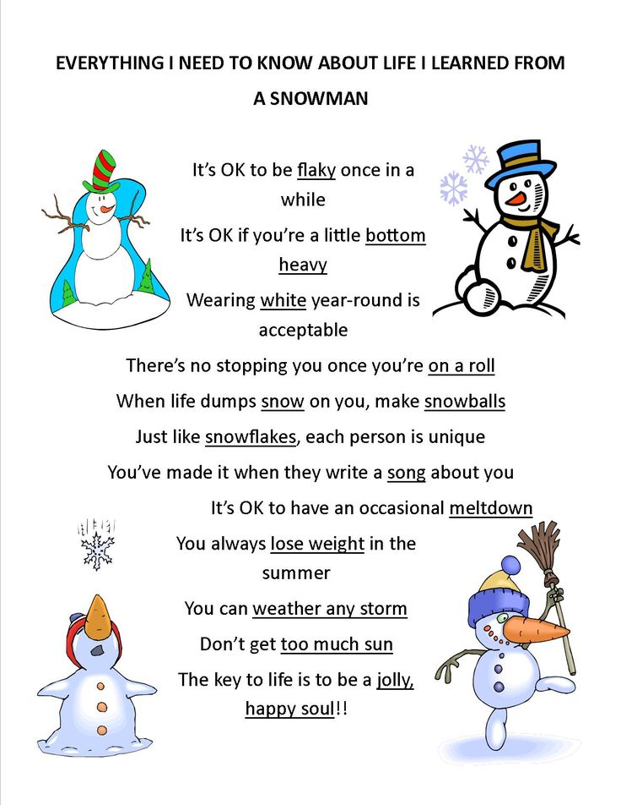
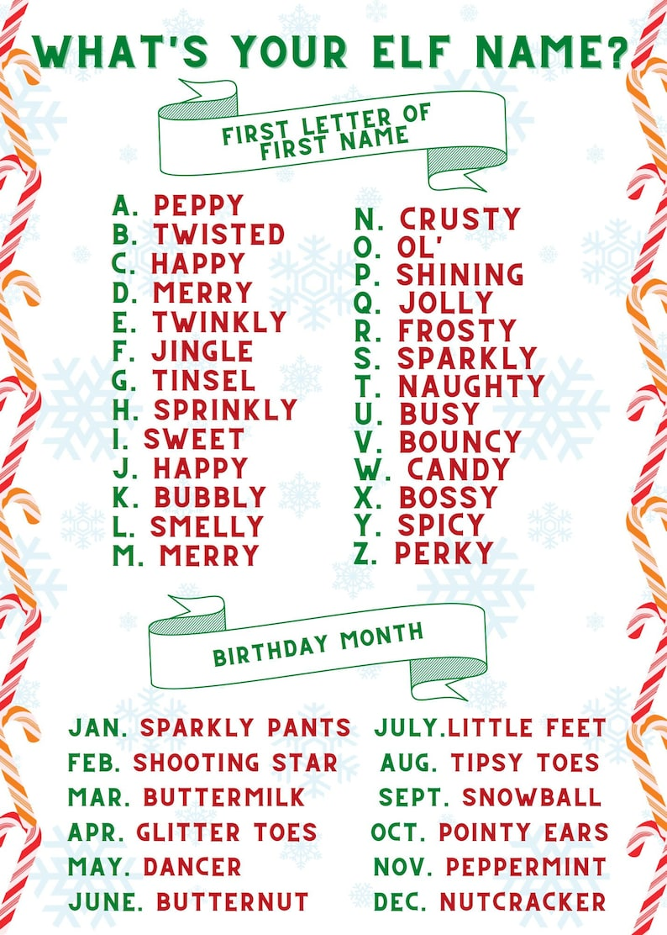

A Christmas message from Jen

Wishing you and your loved ones a joyous holiday season. May your days be filled with warmth, happiness, and cherished memories.
This holiday season is a time of joy, reflection and looking forward to the future. As we celebrate, we honor the bonds that make our community so special. We are profoundly grateful for your trust and the vibrant community we’ve built together at Points West Living.
As we embrace the new year, let us continue to foster the spirit of community and compassion that defines us. Thank you for being an integral part of our family.

With warmest wishes,
Jen Montgomery



