Points West Living Moose Jaw
January 2026




Bettie G-January 7

Darolyn O-January 9
Sandra E-January 18
Rudy M-January 26

____________________________________________________________

Verna Cook

Just a reminder. We are missing a lot of our cloth napkins. If you have any that you may have taken upstairs, please bring them back down.
We are also missing dishes. Please check your cupboards and bring them down.
____________________________________________________________
Reminder:
The housekeepers will be working hard to catch up after the holidays. Please be patient.
Please take caution once the housekeepers have cleaned your suites. The floors will be wet when they leave so, please take your time entering your suite.
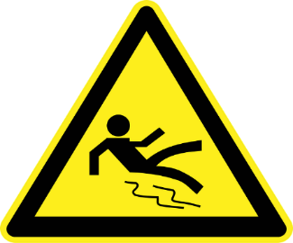
Cribbage Tournament
Wednesday, Jan 21@7pm

Social Hour
Sat Jan 3 & 17
North Common Room

Catholic Mass
Friday, Jan 23@10:30am

United Worship Service
Tues Jan 6 @2pm

Party Whist
Tuesday, Jan 27 @7pm

Catholic Mass
Friday Jan 9@10:30am

Whist Tournament
Tuesday, Jan 13 @7pm
Dusty Old Farmers
Thursday, Jan 29
7:00 pm

Greg Gower music
Thursday, Jan 15 @7pm
50/50 Draw
Friday, Jan 30
10:30-12pm

Winter Prevention Fair
Friday, Jan 16
North Common Room
2:00-3:30pm

Hot Chocolate in the bistro
Friday, Jan 30
2:30-4pm



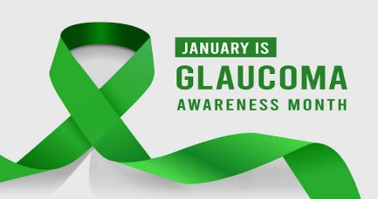
Glaucoma Awareness Month

Glaucoma Awareness Month is observed in January to raise awareness about this serious eye condition, which is a leading cause of vision loss and blindness worldwide. The goal is to promote the importance of early detection and regular eye exams, as many people with glaucoma are unaware, they have it. The signature color for glaucoma awareness is green, symbolized by a green awareness ribbon.
Early detection and treatment can prevent vision loss and blindness caused by
glaucoma.
About glaucoma
Glaucoma is a group of eye diseases that damage the optic nerve, often due to abnormally high pressure within the eye.
- Irreversible damage: Unlike cataracts, vision loss from glaucoma cannot be restored, though early treatment can slow or prevent its progression.
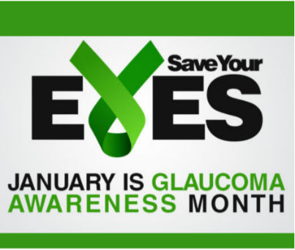
- No early symptoms: Many people with glaucoma don't know they have it because it often has no early warning signs. Vision loss begins with peripheral vision and can advance to a "tunnel vision" effect.
Risk factors
Anyone can get glaucoma, but certain groups are at a higher risk:
- Age: People over 60, and African Americans over 40.
- Ethnic background: Individuals of African, Asian, and Hispanic descent.
- Family history: A family history of glaucoma increases your risk.
- Health conditions: Those with diabetes, high blood pressure, or who are severely nearsighted.
What you can do
To protect your vision from glaucoma:
- Get regular eye exams: A comprehensive dilated eye exam is the only way to detect the disease in its early stages.
- Know your risk: Talk to your family about their eye health history and your personal risk --factors. Spread the word: Use Glaucoma Awareness Month to start conversations with friends and family about eye health.

Moose Jaw Fire Department
Fire Safety Tips for Older Adults
Knowing what to do in the event of a fire is particularly important for older adults. At age 65 and older, people are twice as likely to be killed or injured by fires compared to the population at large and with our numbers growing every year it’s essential to take the necessary steps to stay safe.
Make sure a fire never starts by following these simple tips:
- Don’t reach danger! Wear tight-fitting or rolled up sleeves when cooking and don’t reach over a hot burner. Always stay in the kitchen when you are cooking, never leave cooking food unattended. Cooking fires are the number one cause of fire injuries among older adults. If you need to step away, you should turn off the stove.
- Always blow out candles before leaving the room.
- Ensure items that can burn are one meter (3 feet) away from space heaters
- Avoid overloading the electrical outlets. Extension cords should be used only as a temporary connection.
- Avoid cords running under rugs, which can damage the cord and cause a fire.
___________________________________________________________________

Jokes About Winter
- What bites but doesn’t have teeth? Frost.
- What happens when you catch a cold? You get cabin fever.
- What does Frosty’s mom put on her face at night? Cold cream.
- Who is Frosty's favorite aunt? Aunt Arctica.
- What do you call a snapshot from the North Pole? A polaroid.
- What is the Mexican dish that snowmen like? Burrr-ito.
- What do the elves eat for lunch in the North Pole? Cold cuts and chilly
- What did the tree say after a long, cold winter? What a re-leaf!
- What do you call a ghost in the winter? Casp-brrr.
- What did the icy road say to the car? Wanna to go for a spin?
- What does a barbershop serve in winter? Cold cuts!

To our residents
Your generosity is not to be outdone. The employee care partners thank you for your generous Christmas gift. We appreciate your kindness each and every day.


____________________________________________________________

A huge thank you to everyone that purchased and hand made items to decorate our Donation tree.
All of the donations went to help the homeless at Willow Lodge.
____________________________________________________________

Thank you to all who donated to the Salvation Army Christmas Fund. Together we raised $ 327.00.

Bingo Reminder:
Effective January 1, you will pay 50 cents to play. The caller will collect the money from your table before the games begin. The money collected will go into the pot.
On Friday January 16, 2026, we will be hosting a Winter Prevention Fair. Please be sure to come down, there will be a lot of valuable information for you. The following will be here with displays:
- Moose Jaw City Police
- Moose Jaw Fire Dept
- Hearing Aide Care
- Coop Pharmacy
- Kinesiology


Bus Schedule is as follows:
Monday - 2pm Walmart
Tuesday - 2pm Co-op & Rexall
Wednesday - 2pm Superstore
Thursday - 2pm Shoppers
Friday - 2pm Banking

On behalf of everyone, we would like to thank our residents and their families for joining us and making our Annual Christmas Gala so special.



What Kind of Day Shall I Choose Today?
Today I can complain about my health,
Or I can celebrate being alive.
Today I can moan that it is raining
Or be joyful at all that grows in the rain.
Today I can regret all I don’t have,
Or rejoice in everything I do.
Today I can complain that I have to work,
Or give thanks that I have a family to provide for.
Today I can whine about the housework,
Or celebrate having a home.
Today I can cry over the people who don’t care about me.
Or be happy loving and being loved by those who do.
I choose to have a good day today!!

